Assessment – 1

Information Systems Critical Analysis

Name: Mohammed Zhoeb

Student Id: 00287693T

Subject name: Foundations of Information Systems

Subject code: MIS500

Latureae is a health and wellness company which was been established in the year 2000 providing the wellness services to all Australians. Delivering its product and services to health having an in-depth knowledge in minerals, herbs and nutrients and vitamins. Using the porter value chain model the company’s primary and secondary activities can be illustrated.

Michael Porter developed a strategic tool for analyzing and managing the value chain of the specific company. The value chain is a combination of the various systems of the company which help in generating revenue for the company. This value chain has consisted of various sub systems which pictures the entire process from start to finish ("What Are the Primary Activities of Michael Porter's Value Chain?", 2019).

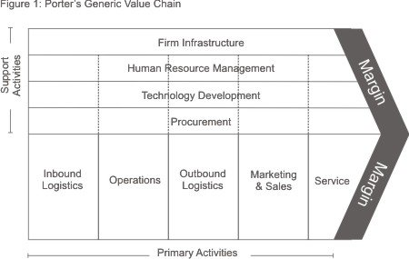

The value chain has been classified into two categories which include primary activities and secondary activities.

**Primary Activity:**

The primary activities involves in the product development, its maintenance and support of the product. The main components of the primary activity include:

* Inbound logistics
* Operations
* Outbound logistics
* Marketing and sales
* Services

**Secondary activity:**

These activities act as a support to the primary activities. Taking an instance of the operations which is been supported by the procurement which is a secondary activity ("Porter's Value Chain: Understanding How Value is Created Within Organizations", 2019). The various components of the secondary activity include:

* Procurement
* Human resource management
* Technological development
* Infrastructure

Discussing about the primary and secondary activity of the Latureae which was established in 2000 with its mission statement of bringing the wellness to everybody.

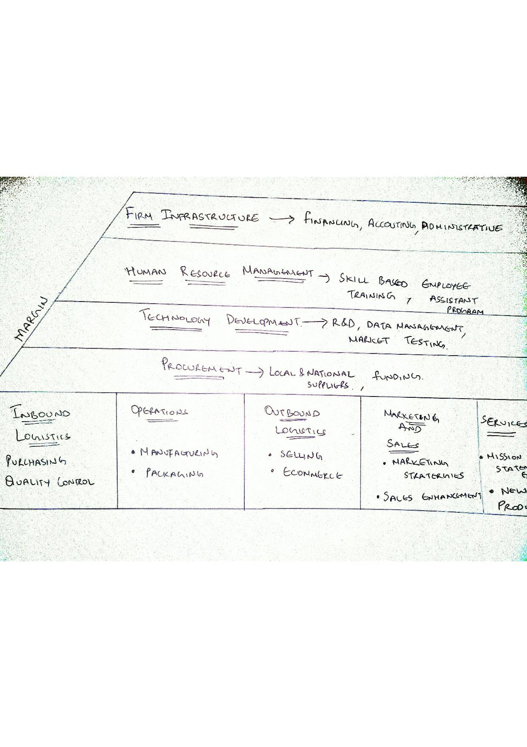

**Primary activity:**

1. **Inbound Logistics:**

As this involves the buying of the raw materials which include API (active pharmaceutical ingredients) and storing of this is included in the warehouses where the particular standards are been maintained according to the FDA. The product should be stored in proper position to prevent the contamination and can be easily checked at regular intervals of time ("Understanding Pharmaceutical Warehousing - Kanban Logistics", 2019).

**Quality control**: In manufacturing quality control is far more important to ensure that the customer receives products free from defects and their needs are met. This might help to gain customer loyalty, reduce the risk and helps to maintain the brand of the company ("Quality Control In Manufacturing", 2019).

1. **Operations:**

**Manufacturing**: It is a process where the raw materials are converted into final products having special physical and chemical properties. Process manufacturing industry usually uses natural raw materials in which Latureae can be compared ("Manufacturing Process - an overview | ScienceDirect Topics", 2019).

**Packaging**: It is a part of operational department where the finished product is been packed before its shipment to the customers. Packaging plays an important role as it helps to maintain the quality of the product.

1. **Outbound logistics:**

The company products are mainly sold to the supermarkets, healthcare professionals and health food stores who are in contact with the patients and clients respectively.

The company Ecommerce site also sells the company core products. Nearly 100000 customers are been served every week by the company products.

1. **Marketing and sales:**

Latureae main approach in terms of marketing is to enhance the revenues with 15%. Utilizing the marketing strategies in social platform might lead to the enhancement of the online sale by 15% in future.

1. **Services:**

The main aim of the Latureae is to bring the wellness for everybody which is been mentioned in its mission statement.

Supplying the new products to the health professionals as well as health supplements to the whole family

**Secondary activity:**

1. **Procurement:**

To maintain the high demand and production standard the procurement of the raw materials is been done from both the local and national suppliers. Latureae has about 2000 different levels of suppliers who supply their raw materials to the company.

**Funding:**  The governments provide various funds to the organizations to improve health and wellbeing of all the individuals. For instance the commonwealth standard Grant agreement is an example of funding done by the government ("Grants and tenders", 2019).

1. **Human resource management :**

Latureae provides various skills based training programs to enhance the skill base of the employees.

The company might be bringing the employee assistant program to reduce the employee turnover rate by 25%.

1. **Technological development:**

Latureae utilizes the R&d to bring the new innovations and products to maintain its position in the market.

Redevelopment of the data management to make the company ahead for 5 year in terms of technology

Market testing is done to find out whether the product is right one and the price placed is reasonable or not, based on such findings the product is launched in the market ("What is Market Test? definition and meaning - Business Jargons", 2019).

1. **Infrastructure:**

There are some company’s support systems that allow the daily operations. The various necessary infrastructure that include are financing, accounting, administrative, general management etc can be used as they are advantageous.

**Sub activity for the primary activities:**

**Inbound logistics:**

Outsourcing of quality control can be done by making subcontracts with them. This might help to focus on core areas of the company.

Warehouse can be used for storing the other company’s product which might help in generate the extra income.

**Manufacturing:**

This involves in having record of the manufacturing process which is to be done in regards to the standards provided by the health law to avoid risk.

Packaging has to be done properly to avoid any sort of product rejection

**Outbound logistics:**

As the company operates in a large scale and requires proper mode to product delivery can be done by using the trucks and mini vans. This might help in producing the employment opportunity.

Running the ecommerce site might also lead to have an special IT team to maintain the site without any errors and also customer complaints has to be carried out.

**Marketing and sales:**

Examining of the product and market standards are one of the sub activities which leads a lot of cost but this might helpful in the long run helping in illustrating the sales.

Sales create a value by selling the product to the retail and wholesale which might help in generating the income

**Sub activity for Secondary activities:**

**Procurement:**

Addition of the new staff or team for making out the call for checking out the prices from different suppliers to find out where the best price is been provided.

Adding up the legal team to make arrangement of the contracts in regards to the funding

**Human resource management:**

The various sub activities that are involved in HR is to make a job specifications based on factual materials collected and conducting interview. This might have a good value because it helps to select the right person for the business.

**Technological department:**

Updating the data might help the company to be ahead in the market having cutting edge technology.

Investing in the R&d might add value within the long run of the company.

**Infrastructure:**

The finance department in spite of having a sub activities it doesn’t add much value only the receivables have value to the company the others will serve as expense to the company.

**Links between the activities:**

1. In regards to the sales and marketing application of the marketing strategies can be done by having a good skill in the field which can be done by human resource department by various skill based training making a link between the human resource management and marketing.
2. For proper functioning of the ecommerce site of the company proper management of the data has to be done this creates a link between the outbound logistics and technology development.
3. Market testing might help to find out the response of the product within the market which might also help in the marketing of the product prior to its launch.
4. Investment in R&d might help to produce a product of very good quality which helps to provide better service to the customers.
5. Funding might help to increase the operational activity of the company helping out in generating more revenue
6. Procurement of the products from the suppliers helps inbound logistics in purchasing the raw materials for the production purpose.

**Recommendations for enhancement of the value to the customers:**

By cutting down the investments in the field of marketing rather than R&d and might help to provide more service to the customer.

Making user friendly interface of the ecommerce site can help out the customer in getting the product of their choice rather than burning the time in search

By utilizing the proper funding from the government bodies in right planning might help to cut down the cost of the product making more affordable to the customer.

Quality control has to be done in an effective manner to reduce the risk of batch rejections

**REFERENCES:**

What Are the Primary Activities of Michael Porter's Value Chain?. (2019). Retrieved 8 October 2019, from <https://www.investopedia.com/ask/answers/050115/what-are-primary-activities-michael-porters-value-chain.asp>

Porter's Value Chain: Understanding How Value is Created Within Organizations. (2019). Retrieved 8 October 2019, from <https://www.mindtools.com/pages/article/newSTR_66.htm>

Understanding Pharmaceutical Warehousing - Kanban Logistics. (2019). Retrieved 10 October 2019, from <https://www.kanbanlogistics.com/understanding-pharmaceutical-warehousing/>

Quality Control In Manufacturing. (2019). Retrieved 10 October 2019, from <https://www.graphicproducts.com/articles/quality-control-in-manufacturing/>

Manufacturing Process - an overview | ScienceDirect Topics. (2019). Retrieved 10 October 2019, from <https://www.sciencedirect.com/topics/engineering/manufacturing-process>

Grants and tenders. (2019). Retrieved 10 October 2019, from <https://www.health.gov.au/about-us/what-we-do/grants-and-tenders>

What is Market Test? definition and meaning - Business Jargons. (2019). Retrieved 10 October 2019, from https://businessjargons.com/market-test.html